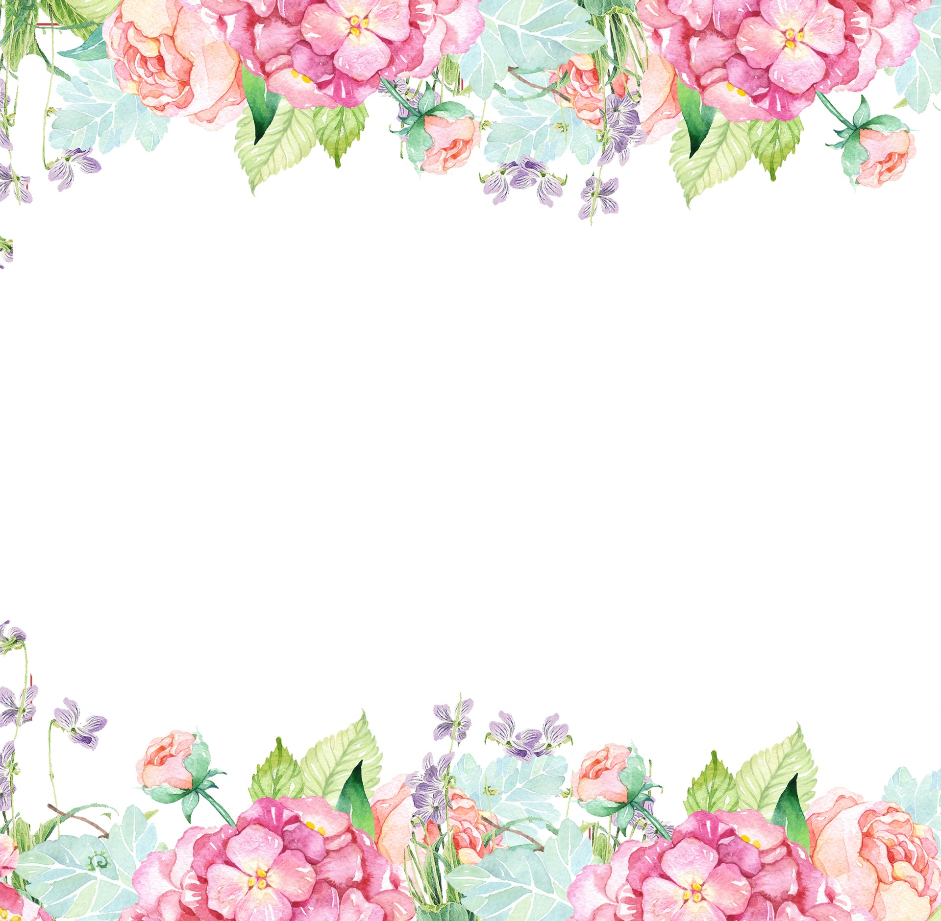

Name: Lauren Jones Initals: LBJ
Birthday: February 5
Preferred t-shirt size? Medium
What is your favorite color? Pink
What is your favorite flower/plant? Orchids and Hydrangeas
Where are your favorite places to shop? Target, Amazon, Lululemon, Homegoods
What are your favorite restaurants? Masa, Backwoods Crossing, Chick-fil-a
What do you collect (candles, foxes, etc.)? books for my classroom, volcano candles
What is your favorite cold drink? Water
What is your favorite hot drink? Black coffee or decaf tea
What is your favorite sweet treat? Anything gummy or chocolate with caramel
What is your favorite salty treat? Cashews, pretzels, pistachios
What is your favorite fruit? Granny smith apples, grapes, cantaloupe, watermelon
Do you have any food allergies? Nope!
Interests: Home renovation projects, watching baseball, and reading
UMOJA House:
Wish list for your classroom? https://www.amazon.com/hz/wishlist/ls/3IH2HIZ82I5F6?ref_=wl_share

